Test matrix for Lab 4, SDEV 300 6381, John Leckie

The following table outlines testing scenarios for Lab 4. Pylint results are first, followed by a table of the testing matrix, and then screens of the multiple runs used to obtain the results that went into the matrix. In the screenshots that appear below the matrix, there will be titles indicating to which test case(s) they are applicable. Following the screenshots, there is a table recording the results of the Password hash check exercise.

PYLINT SCREENS

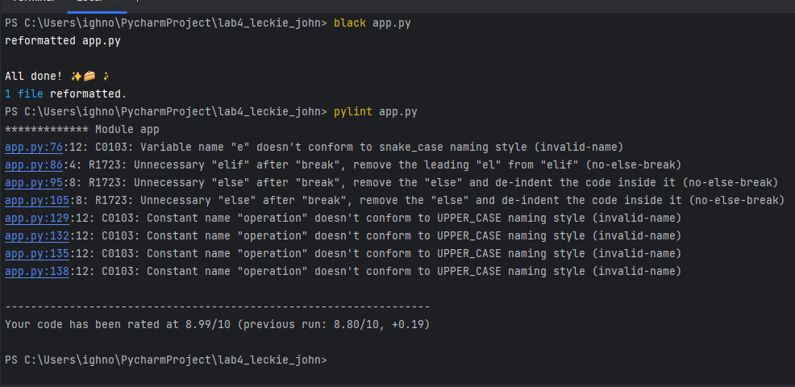

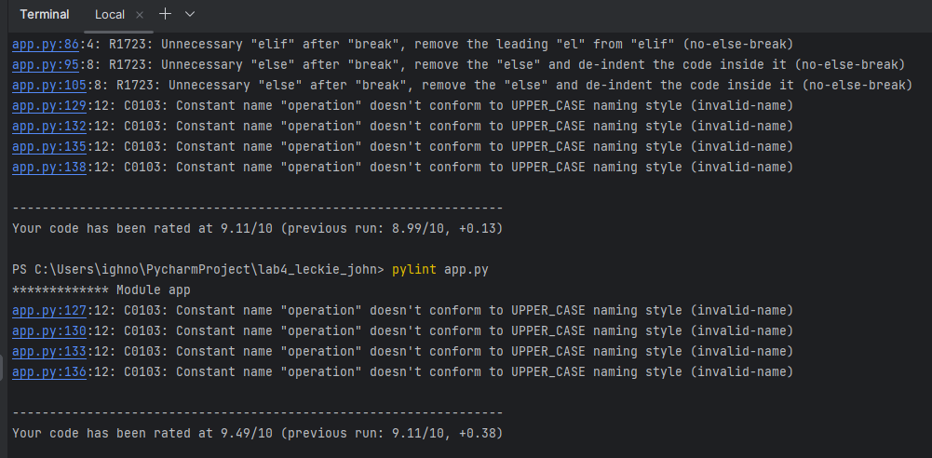

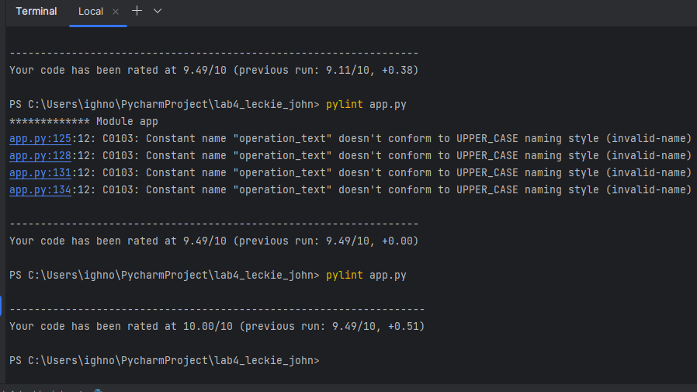

The interesting thing about pylint this time was that I didn’t understand why it repeatedly insisted that my “constant” needed to be in all-caps to conform to a naming convention. It was not being used as a constant, but to get the 10.00 I went ahead and capitalized it.

I have some bad habits about if/then/else that pylint had to remind me of. I was sure if I did what it told me that it would break the program. It did not.

TEST MATRIX

|  |  |  |  |  |
| --- | --- | --- | --- | --- |
| TEST CASE | HOW TESTED | EXPECTED OUTPUT | ACTUAL OUTPUT | PASS (Y/N)? |
| 1. Immediate exit check | On being asked if they want to run matrix math, a Yes/No question, User enters No (n or N) | Clean exit of program | As expected,  See Figure 1 below. | Y |
| 2. Phone number ten digit and ZIP +4 enforcement | When asked for phone number and ZIP, with template examples of expected inputs, user repeatedly violates with non-numeric or pattern-breaking test entries. | Program should repeatedly remind the user of the expected format in loops for both input types until the proper format is observed. | As expected,  See Figure 2 below. | Y |
| 3. Matrix element entry enforcement | After format and entry method is described, user will repeatedly violate the requirements (as seen in screenshots) | Program should hold user to required format for all violation types, repeating entry opportunities for each row of the 3x3 matrices | As expected,  See Figure 3 below. | Y |
| 4. Matrix mathematical Function selection enforcement | Once matrices are entered, user must enter a letter choice for the desired function. User will violate this function repeatedly. | Program should remind the user of what is expected in order to select a function until a viable choice is entered. | As expected,  See Figure 4 below. | Y |
| 5. Addition check | Program function check, no user input evaluated. See Figure 5. | Numpy results presented to the user should be mathematically correct. | As expected  See Figure 5 below. | Y |
| 6. Subtraction check | Program function check, Figure 6. | Numpy results of matrix math should be correct | As expected, See Figure 6 | Y |
| 7. Multiplication check | Program function check, Figure 7 | Numpy results of matrix math should be correct | As expected, See Figure 7 | Y |
| 8. Element-by-Element Multiplication check | Program function check, Figure 8 | Numpy results of matrix math should be correct | As expected, See Figure 8 | Y |

FIGURE 1, INSTANT EXIT

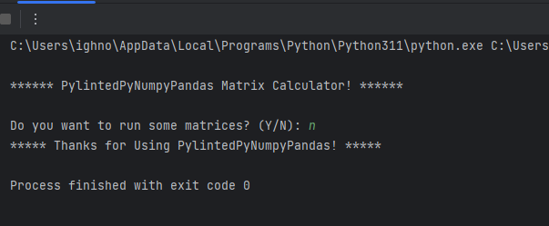

FIGURE 2, PHONE AND ZIP ENFORCEMENT

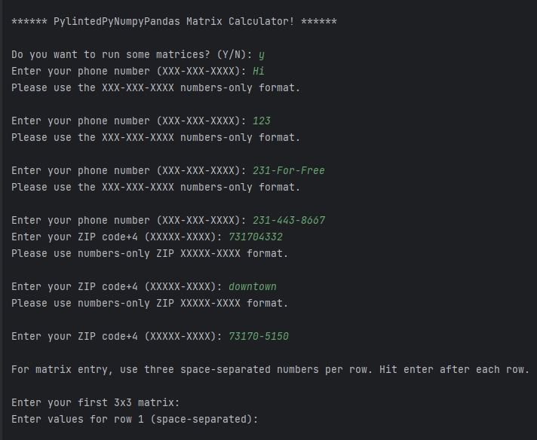

FIGURE 3, MATRIX ENTRY ENFORCEMENT

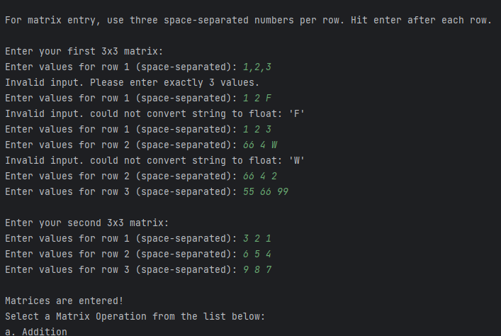

FIGURE 4, MENU CHOICE ENFORCEMENT

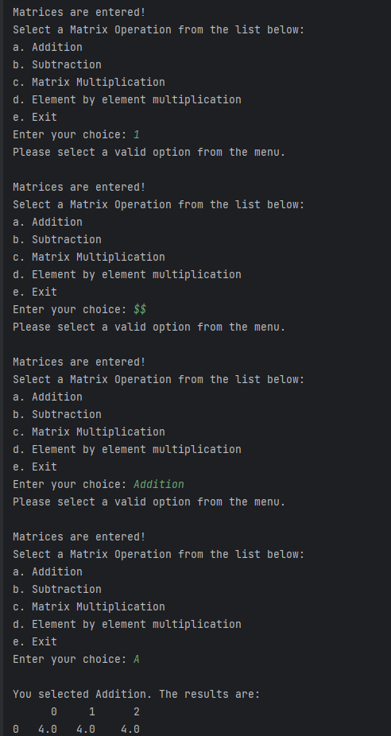

FIGURE 5, ADDITION CHECK

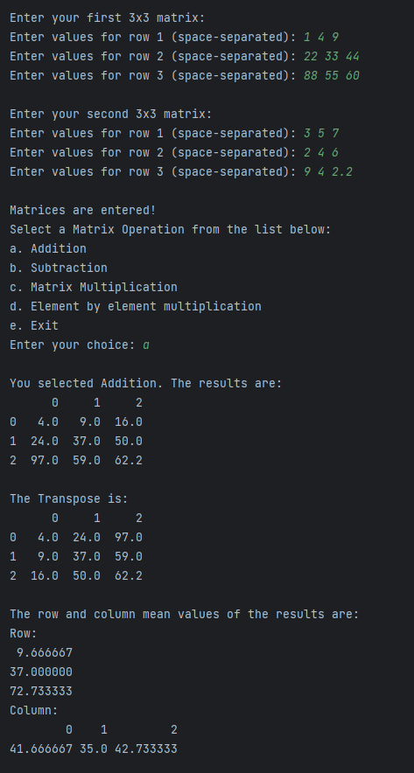

FIGURE 6, SUBTRACTION

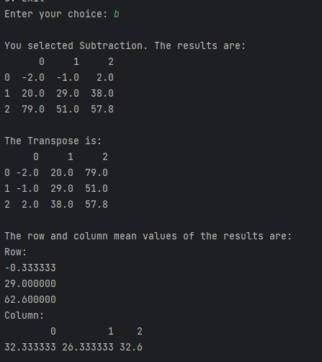

FIGURE 7, MULTIPLICATION

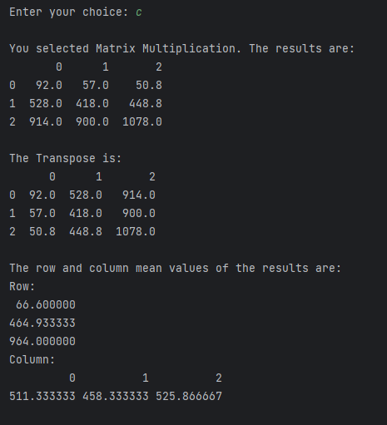

FIGURE 8, ELEMENT-BY-ELEMENT MULTIPLICATION

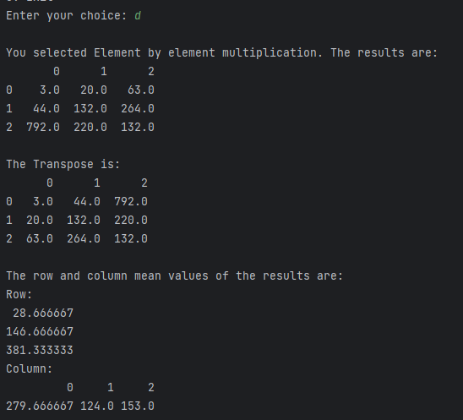

Lab 4 Password Cracking Table

|  |  |  |
| --- | --- | --- |
| Password | Hashes | Crackstation? (y/n) |
| CrackThisMotherCracker | 046d4026b621b8b021d0abc1b666bc26  4ce7db911510a3cca84838569399b6aa9ed598ca6d897a7098fe294237c80378  e773b709a6c4d09f6af2cb9a93115474ea6ccb8c8e17486a6196cc11de7ee6ca4cd83141f95dff5d3351ddcdea14fb95f00ea302466cbbc61f6f25d2fa3bbff4 | N (Perhaps the length and the individual word capitalization helped here.) |
| wordpass123 | 5b549e09fc0b6777ec10f35d9a76f92c  34fe833b440d4f44d3bdcfa688990db5b63a9d698dc15141bf00bc265b2993b2  bad7182bd6d57084adc02fa962f03a5b506a1f9a32a96c2e540a38514edc90b5953d7b0fe00bcdafcbd86237a4e7f3c6582b36e95daaec2fb4afe6bad389dd94 | y |
| nongrata9 | cba3be8bde01c2c35ede175d388c4ede  ef1d3cafef9576ec220c0d69dd2c11eb9be8539b719cfc9b780d442395f8e359  0ebb36f467bc5140862c04cbb0f5fcf37168d06004a9fefbaf94171f2ed085df635c11e4cc61cc0c94af18758dbde1b774d20f05c31b9bb4ed7d47aa6376397e | y |
| NoNgRaTa9 | 9c29557a69135b42dac7df87edbcb466  2c6ead62f7d26d1f65d4b3f1fe3e083206fc46b8220f5cbf2cd0008885409e96  f999494805c2ae7389fdfaec39f3b6cdfcd09bb950cf940abd399f716336f8286de3eafabc3f3f748ec4a1595ccf60e89e252ff2a63dba899e3c682966c761bd | n |
| 1qazXSW@3edc | 53f82bd77f6ae45ceae4de4a9c778f41  24d108079a91278618901344e67ba0164b34de44df80fc41f3862f58d0605cd1  cf281029f498e1d1df6c6d4074d3df1ba63599d68d5b541f382397c8506001427f88758682c453f8c531054e1ce816f8b02e48cbba120b312456df0546251255 | Y (!) So much for the marching-up-and-down-the-rows-alternating-shift-key-usage. It’s as if many people do this! |
| NiagraFalls8675309 | ecd78139cc8bd780d12c1dc241fba6e0  70b8373913780948f830f3ff5280b1258eef991d52bf4f193b7b54e9274e9bc7  0d56f25fded78beaeb2a9b75b324b1b63356615b868a58df00ec2f3a2323640d00f7b709b2c804fb998811b4dfe816ef54d62d6ca374a13a2cceb1bfcab6dfe6 | N  Though known words were used, they were capitalized, and though the number is very genX recognizable, it seems it was random enough when combined with NiagraFalls to be complex enough. |
| 0a7iyl2icaYo6+eja5he  (NORTON random) | 2928943a8bc98a1155f8dda65f09720b  d97f5138819f6702fcbedf77f3aea3d914edfb51535d1e7bd41dff9291a0cd5f  af179e2f772e83f527cf0833ff45167becb08252cfa9a7675b66d8ebbfef21c12f052557d6511060273a25164af81d6a823d9a882f81d2cb7a2a8258d11bfb69 | n |
| wro$epLdr2c0icru3it1  (NORTON random) | d820a6286cfb3e1a36202fe373f934a5  ee9b19793a7f5f37eddcd3a146a4b5dc0c9e4292add315693298a3773beed12d  0f385b829872d99b5f609aa917ca86b1d8397235131714276665bf74d1e43769356d276159baed1f9243f062ecd4c7f40545ce2038f2c8d0516cd574f4c0d393 | n |
| NonDASHgrata9  (SALT added to middle of previous easily cracked PW) | ae1ffc8a259209312c89b0588da84693  f263689a455152d909d4cb95e95032c82c4b9a51748ba9e7e848f9295fa73f87  2737630aab12421ee8379f7cde9ef2dbe3ea0e4f43727b436e48cc97857c39d32f1538eec3a91703acced20cdae4788d20c4cbe651bc88cbfa3853f09a6a5f6b | n |
| WordJDLpass123  (SALT added to middle of previous easily cracked PW) | 9b1d4ed9b1c8b686aa8079e208df405f  a062dcc764ec87a7494bf3fa910c4d976c5c8fe0ab5df326fbfa0277c62b99f1  b21818209b86fe9d56492acc0bebc51847cf62822df0df2cdbfb6a0ccdc667803d6e8fd55e180368f309e51a011e89adc9b3eee3d32450e10c04f5b740ad7e79 | n |
| Johnpassdavidword1234leckie  (Salted my full name, wove it into an otherwise well-known failed password) | 74619691775c71a972d6f122cf5cf4dc  697d45c6f3c387ad2b05789906c6f63f06d690a7c4726e16e4b20e8448dd1b1c  3ce3ab032b0583d3d679b55d81f1ab99f07da5b9b85034b90dfd5c160d83b3c086c3169f025d67081839ea8e55b802b0f3cb75e1770c084f297ed287db3e4164 | n |
| FilterKing1970 | dff88f650fa190aff04edf3e36831ea8  06d44870d0e7daf204c955b0979a85c213d836a7933a8ab1bde2ca64b11a2a77  96ab37785db976fc3977cd9c872993fa532ea523be91440ebaa75f7453ec5a7407b3967390fd66049953b9f675e06248210c24cb7e02fd70f9a2727a73203ed5 | n |
| davidtoddjoy707275  (When Mom passed and Mom and Dad’s estate went to us, we found out this was the password she was using for many things. Kids’ names and birth years... oh, Mom.) | cde078212332d2f95a2d0f73c9390f5d  e30b8cbf4baac16cacd1fae3f4a32421685a872ba2f382140c0e1160676d7be3  b8dda976803831b966ed69955ada390e3a342dcec9d152cd536e5b036ac0b67933752de71e4d68601ef47ae38d71feef132d1273456f92ce42fe15a51e6ddc11 | n |
| gooberdot1601 | 1f68bf14a2d26392d60fd86885245c61  1df6893ec632661fc4039a3566ac922dabcaac5e28f9135606cdf3348e254b1b  8f7185fbd1944e10d5beee41a7d0d62f180fdf22bcc51551bf63985f7830d9d82ffe74295194b74678f6436d50fe4bf690de66ec1ad7e83e385a14fc5a7aa3a0 | n |
| At this point, CrackStation’s Captcha started asking me to prove I was human in ways besides just clicking the checkbox. No doubt now I’m on someone’s list as a possible dark web hackerboi. |  |  |

This was a fun exercise. Mostly the results were as expected. I spent 20+ years in the Air Force with a security clearance and a chipped access card. My habits are really good in this department. Even now, I develop classified maintenance instruction materials for foreign and domestic customers of our products, so we are always vigilant and security-aware.

I was CERTAIN that mom’s password would be easily cracked. I mean, years, names, what grandma doesn’t do that? I think in this case that length can sometimes add complexity that makes up for common name/word usage.

I had not encountered ‘salting’ prior to this exercise. Even with all my time in the military, I was never briefed on this technique. That is very cool. It made me want to go into my password encryption app and begin salting my passwords.